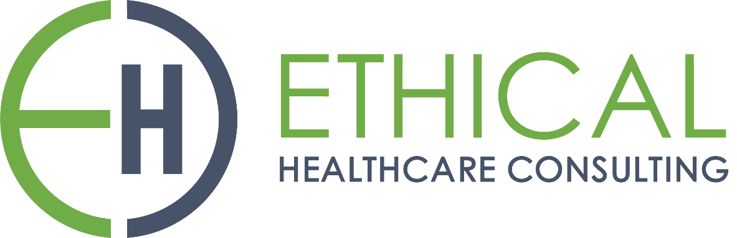

**HealthTrust Europe LLP: ITT to establish a framework agreement for consultancy solutions and advisory services Contract Notice (FTS) Ref: 2023-041574**

**Technical Response – B2_Contract Performance_Ethical Healthcare Consulting**

B2: Please provide details of any process you have in place that will ensure you meet timescales with the Participating Authority. Your response should include details of how projects are planned and how you will ensure sufficient time is allocated to each project. Your response should include:

• how projects and timescales are planned, and sufficient time allocated;

• how projects and timescales are managed, this must include details of how you prioritise; and

• how key dates and progress updates are communicated to the Participating Authority, this must include process details of notifying the Participating Authority of delays.

**EHC Response:**

**• how projects and timescales are planned, and sufficient time allocated;**

EHC’s approach to project planning and timescale allocation is designed to ensure efficient and effective project execution. We employ an Agile and iterative methodology, which enables us to promptly mobilise specialised teams and initiate projects without unnecessary delays. Our vast pool of resources includes not only project managers but also clinicians, business analysts, and subject matter experts, bolstered by strategic partnerships for additional expertise when needed.

Key to our planning process is our dedicated deployment team, which assumes a critical role in defining project scopes and transparently communicating objectives, deliverables, constraints, and assumptions to our clients. To ensure that all team members are well-versed in our tools, practices, and delivery approach, we conduct a detailed onboarding program.

For an in-depth understanding of our project planning process, we provide detailed insights in our supporting documents, specifically the***‘SD19 Delivery Manager Playbook****'.*

Incorporated within our Agile delivery framework is a dedicated "Sprint 0" phase, which focuses on comprehensive planning. During this phase, we actively engage with stakeholders and reconfirm project scope, laying a robust foundation for seamless project mobilisation and execution.

EHC place a strong emphasis on meticulous onboarding processes to align our teams with the specific requirements of each project. While this may entail a slight delay in the initial project start, we prioritise the assembly of the right team, recognising that this proactive step significantly mitigates the risks of potential project delays or failures down the line.

Our approach to managing and scaling multiple projects efficiently is grounded in strategic planning. The initial step involves defining the scope of each project and identifying key stakeholders to ensure clear objectives and expectations.

Throughout our delivery process, we maintain a thorough internal kick-off meeting as part of our deployment methodology. This meeting serves as an important alignment point for project scope, budget, and timescales. We also conduct planning sessions with subject matter experts, which are integrated into our ongoing sprint planning sessions.

Our work is usually organised into 2-week sprints, with planning sessions conducted before each sprint commences. Additionally, retrospective sessions are carried out before planning meetings to incorporate lessons learned into the next sprint plan. This iterative process allows us to set realistic objectives within the allocated timeframes, ensuring clear expectations for our clients and enabling us to identify any additional resource needs necessary to achieve sprint objectives.

**• how projects and timescales are managed, this must include details of how you prioritise;**

Our project and timescale management approaches are comprehensive and tailored to prioritise and meet our clients' needs effectively.

EHC initiate a thorough review and harmonisation phase, where we assess the priorities and requirements of the organisation involved. For instance, in a recent deployment that encompassed multiple organisations, we conducted an in-depth evaluation of platform contracts to identify opportunities for cost savings and service improvements. This process also included strategic planning for contract expiration timelines and inter-organisational support, with a focus on addressing the most complex and time-sensitive aspects first.

Our methodology involves managing various workstreams within large programs to prevent duplication of efforts and ensure efficient use of resources. These workstreams consist of specialised teams supported by clinical expertise, a central team dedicated to building core solutions, and localised workstreams tailored to address specific trust requirements, including integration and data migration.

EHC are committed to maintaining resource availability across multiple projects without compromising quality. This enables us to effectively manage and prioritise tasks while delivering exceptional results.

Our Project Management Office (PMO) toolkit seamlessly integrates with our delivery management practice, emphasising quality output, exceeding client expectations, and delivering projects on time and within budget. This toolkit, powered by Microsoft Apps Technology, not only eliminates additional software costs but also minimises training requirements. Real-time collaboration tools enhance communication and transparency, enabling us to interact effectively with clients.

Our lift-and-shift approach streamlines project management by utilising proven templates customised for each client's unique needs. Additionally, our comprehensive governance controls and standards ensure consistent and effective project management practices across all projects.

To enhance our ability to prioritise and manage timescales effectively, we employ workstream leads who provide regular status reports. These reports enable our delivery managers to closely track progress and make informed decisions regarding project priorities.

In addition, EHC has implemented a robust risk management process that provides a prospective view of potential issues requiring mitigation. This proactive approach is instrumental in prioritising tasks and ensuring that project timescales are maintained.

In summary, our project and timescale management strategy are characterised by a comprehensive and customer focused approach, using our tailored PMO toolkit, dedicated workstream leads, and risk management to deliver high-quality results while meeting our clients' priorities and timelines. For additional information on the tools available within the EHC PMO toolkit, please refer to our supporting documents in *'****SD18 PMO Toolkit****'.*

**• how key dates and progress updates are communicated to the Participating Authority, this must include process details of notifying the Participating Authority of delays**

The example below details a real-life complex laboratory implementation with a client (Note further tasks are under each workstream). We adopt a workstream-based approach, using Prince2, Agile, or Wagile methodologies, particularly effective for large, multifaceted projects. Our expertise extends across various PMO tools, tailored to each project's requirements. We utilise MS Project for visual progress tracking, complemented by our custom PMO toolkit created with Microsoft Apps. This toolkit assists our delivery and project managers in managing risks, issues, and key decisions, facilitating transparent information sharing with clients via MS Teams, a familiar platform for our healthcare clients.

EHC understand the importance of conveying information to different stakeholders and often use visuals to demonstrate progress and blockers. Below is an example of our utilisation of timeline within MS Project.

Our PMO toolkit enables easy information sharing with clients, including recording risks, issues, and tracking milestones. It consolidates lessons learned from previous projects, ensuring relevant mitigations are applied. For instance, in business case projects, we collate all related lessons to proactively address potential challenges before project commencement.

In managing large, complex programs, we adopt a Wagile approach to concentrate on key tasks. Our sprint planning templates can integrate with MS Project Plans or function independently, tailored to the project's complexity.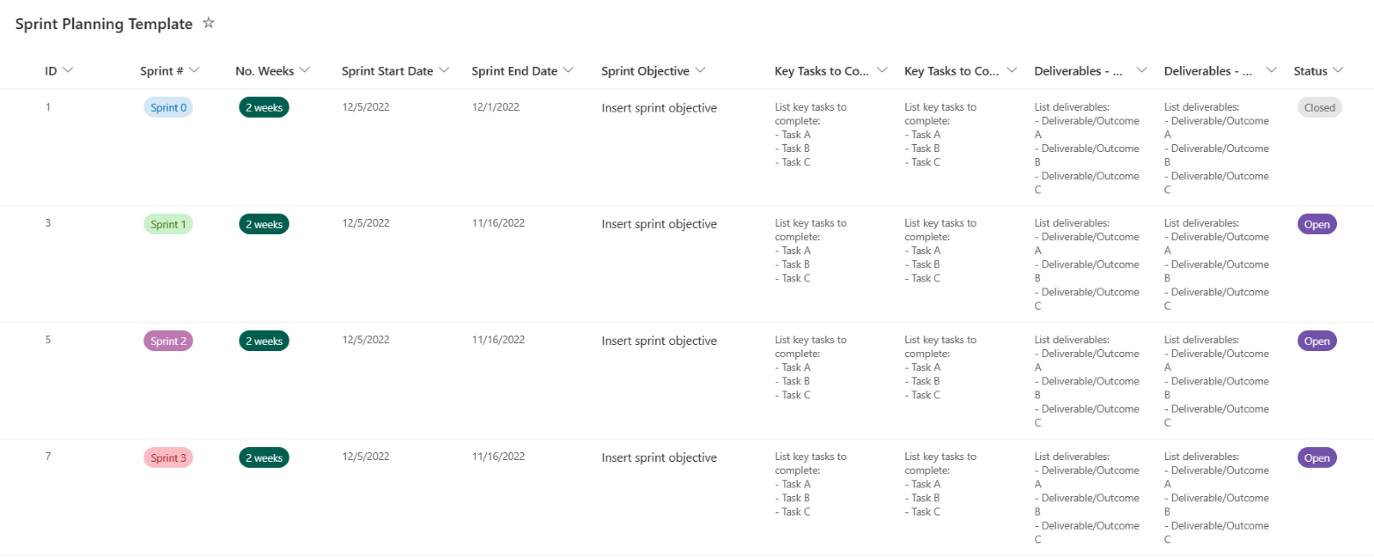

Our PMO toolkit captures risks and issues effectively. We proactively identify risks early through planning sessions, team engagement, and learning from past projects. Regular meetings like stand-ups, retrospectives, and planning sessions keep risk management a priority, with delivery managers actively seeking and implementing mitigations.

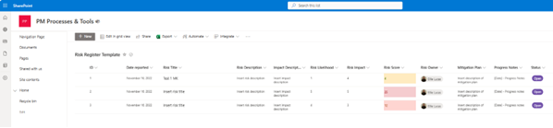

**process details of notifying the Participating Authority of delays**

When delays arise, our approach is swift and thorough:

1. We promptly detect and evaluate any delays as they occur.

2. Before external communication, we initiate internal discussions to brainstorm potential solutions.

3. We communicate with the client openly and honestly. We provide a clear explanation of the delay, its underlying causes, and our proposed solutions, both verbally and written.

4. We diligently investigate the root cause of the delay, whether it originates from our side, the clients, or involves a third party.

5. Engaging in collaborative discussions with the client, we refine our approach.

6. Throughout the resolution process, we maintain regular communication with the client, keeping them informed about the delay's status and our progress in addressing it.

7. Once the issue is resolved, we conduct a comprehensive review of the situation. This review enables us to learn from the experience and implement improvements to enhance future processes.

These risks are communicated at Project Board level meetings regularly. An example of where we have done this previously is shown below.

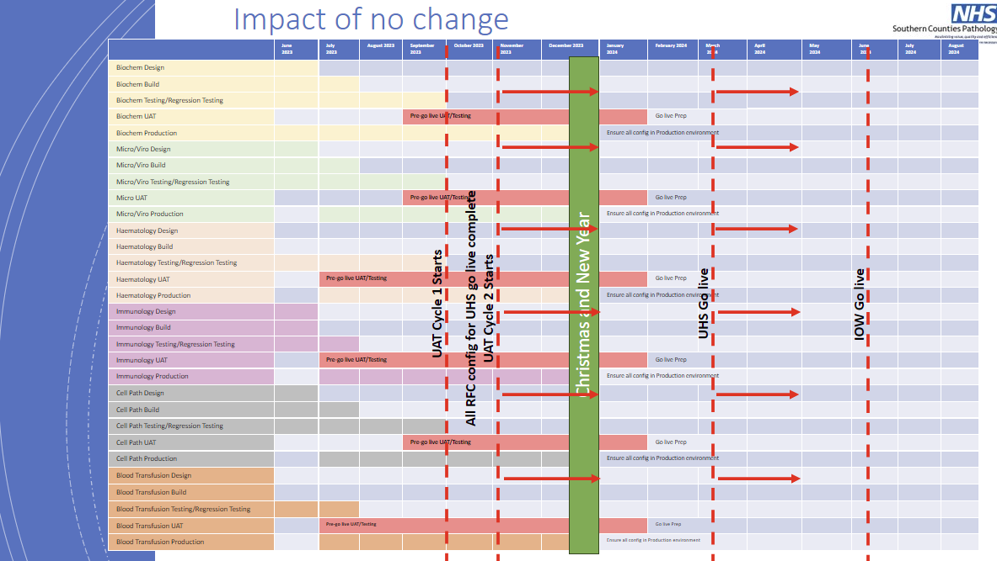

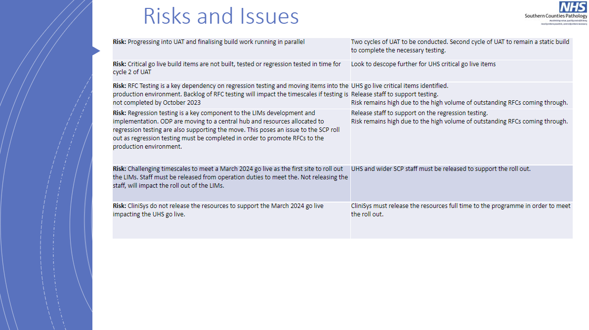

An example of our Project Board report is shown within supporting documentation *‘****SD3 Example Project Board Update****’.*

It is the role of EHC delivery managers to manage unexpected costs through regular capture and review of risks and issues. To ensure there are appropriate mechanisms to manage this, EHC has processes and training in place for all delivery managers as part of the delivery playbook to ensure budget review and risk management is completed consistently.

CMAP is a resource management and scheduling tool used to forecast and manage project resources effectively. It enables delivery managers to identify future resource requirements and manage costs efficiently. CMAP provides a clear view of budget implications, assisting DMs delivery managers in making informed decisions, including forecasting forward scheduling. This assists our teams to proactively manage the budgets allowing for quick corrective actions, such as adjusting resource schedules or addressing additional costs arising from unforeseen issues.

Appropriate governance is implemented at the very start of the project by the delivery manager. All EHC projects have a senior responsible officer as part of every project. Additionally, the delivery manager would ensure counterparts on the client side also have equivalent governance in place to ensure appropriate escalations can take place.

Identification of additional costs are done in various ways. The delivery manager is responsible for running stands up, show and tells and retrospective sessions. Within these different forums the delivery manager will review the risks and potential challenges which could impact the budget. This is review and flagged immediately with appropriate mitigations and communications in place.